**Hippocampal-prefrontal inhibition mediates fear relapse**

Roger Marek1*, Jingji Jin2*, Travis D. Goode2, Thomas F. Giustino2, Qian Wang3, Gillian M. Acca2, Roopashri Holehonnur4, Jonathan E. Ploski4, Paul J. Fitzgerald2,  Timothy P Lynagh5, Joseph W. Lynch, Stephen Maren2, & Pankaj Sah1

1*The University of Queensland, Queensland Brain Institute, Brisbane, Australia*

2*Department of Psychology and Institute for Neuroscience, Texas A&M University, College Station, TX, USA*

3*Department of Biology, Texas A&M University, College Station, TX, USA*

4*School of Behavioral and Brain Sciences, University of Texas at Dallas, Richardson, TX, USA*

*5 Department of Drug Design and Pharmacology, Center for Biopharmaceuticals, University of Copenhagen, Copenhagen, Denmark*

*\**These authors contributed equally to this work.

Correspondence to Pankaj Sah (pankaj.sah@uq.edu.au) or Stephen Maren (maren@tamu.edu).

**Extinction learning is essential to cognitive-behavioral therapies in patients with anxiety disorders, including posttraumatic stress disorder** 1,2 **.  Unfortunately, the extinction of fear memories is highly context-dependent, a property that often leads to relapse outside the clinic.  The hippocampus (HPC) has a critical role in fear extinction** 3-5**, but the precise neural circuit that mediates context-dependent retrieval of extinction is not known 6. HPC projections to the medial prefrontal cortex (mPFC), an area critical for extinction learning** 7**, have been implicated in both anxiety and memory retrieval.  Here we show that feed-forward inhibition mediated by parvalbumin-positive inhibitory interneurons dominates HPC projections to the infralimbic cortex (IL), the major mPFC target of the HPC. Pharmacogenetic silencing of HPC->IL projections prevented fear relapse, and this effect was mirrored by microinfusions of GABA receptor antagonists into the IL to block HPC-mediated inhibition.  These data reveal a novel circuit mechanism for the contextual control of fear, and indicate that hippocampal inhibition of infralimbic cortex is the neural substrate for fear relapse.**

Hippocampal projections to the mPFC have previously been identified 8, however the precise projection patterns and local circuits that are driven by this input are unclear. To determine the nature of hippocampal projections to the mPFC, we expressed channelrhodopsin ChR2) using viral mediated transduction of neurons in area CA1 of the ventral HPC (vHPC; (Fig. 1f), the primary projection site from the hippocampus to the mPFC 9. Whole-cell recordings were then made *ex-vivo* from pyramidal neurons and interneurons (Fig. 1a,b,c) in the infralimbic (IL) prefrontal cortex, whose activity is crucial for extinction 10,11, and vHPC afferents stimulated using 470 nm light (Fig. 1a). Both interneurons and pyramidal neurons in the IL received direct excitatory input from the vHPC (Fig 1d,e, top), with innervation of interneurons being large (mean EPSC amplitude: 237 ± 66 pA; n=9 from 5 rats), and able to drive these cells to threshold (Fig 1d, e, top). In contrast, input to pyramidal neurons was subthreshold (Fig 1e, bottom), but significantly larger to L2/3 neurons with a mean EPSC amplitude of 173 ± 31 pA (n=27) compared to L5/6 cells that received EPSCs with a mean amplitudes of 81 ± 20 pA (n=14; one-tailed Mann-Whitney test: p = 0.046, Fig. 1h).

When pyramidal neurons in the IL were depolarized to -40 mV, activation of vHPC input revealed delayed disynaptic inhibitory postsynaptic currents (IPSCs), Fig. 1d), which is consistent with the strong hippocampus-driven recruitment of investigated local interneurons that generate this feed-forward inhibition. All vHPC evoked synaptic inputs were eliminated by the application of AMPA/kainite and NMDA-receptor antagonists NBQX and APV (n=3; Fig. 1g), confirming the nature of this hippocampal projection to be glutamatergic. This vHPC-driven disynaptic inhibition to pyramidal neurons was large with the peak conductance ratio of IPSC to EPSC in L2/3 pyramidal pyramidal neurons being 1.86 ± 0.67 (n= 20), and 2.44 ± 0.68 (n=7; Fig. 1h, bottom) in L5/6 pyramidal neurons. Randomly selected interneurons were further classified by their intrinsic firing properties, and quantification of vHPC inputs to these neurons revealed a distinct innervation pattern with fast-spiking (FS) subtypes receiving significantly larger inputs (EPSCs) compared to non-FS cells (Fig. 1i, EPSCs: FS: 453 ± 175.4 pA; non-FS: 123.6 ± 50.5 pA, n = 5 each group from 9 animals; one-tailed Mann-Whitney test; p = 0.028). The vHPC driven inhibition consisted of a fast (50-100ms) GABAA-receptor mediated component and a slower (150-1000 ms) IPSC (Fig. 2a,b), which was blocked by the selective GABAB-receptor antagonist CGP55845 (Fig. 2b, purple trace). The fast disynaptic IPSC was found in 88% of L2/3 pyramidal cells and in 62% of L5/6 cells, whereas the slow IPSC occured in ~60 % of L2/3 and ~37% of L5/6 pyramidal cells (Fig. 2c). Together, these results show that the impact of vHPC input to the IL is largely inhibitory. To test if this strong inhibition was capable of suppressing the excitability of pyramidal cells, local electrical supra-threshold stimulation of pyramidal cells was paired with optical terminal release to activate hippocampal inputs (Fig. 2a). Activation of vHPC input prior to local stimulation (150 ms before) led to complete suppression of spiking (n=7, 4 animals; Fig 2d).

Pyramidal neurons in the IL are known to project to the amygdala 12. To investigate whether the vHPC targets amygdala-projecting neurons in the IL, optical stimulation of vHPC afferents was combined with retrograde tracer injections in the amygdala (Extended Data Fig. 1a). Amygdala projecting neurons received excitatory vHPC input (9/10) of similar amplitude as that to randomly selected IL pyramidal neurons. Moreover, these amygdala projecting neurons also received disynaptic IPSCs (8/9 with a fast IPSC and 3/9 showed slow IPSCs) (Extended Data Fig. 1).

We have shown that vHPC input to the IL generates strong feed-forward inhibition that suppresses the activity of pyramidal neurons. To confirm that local IL interneurons are responsible for this feed-forward inhibition, we first used local electrical stimulation in the presence of NBQX and APV to isolate inhibitory synaptic transmission. Stimulation within the IL evoked IPSCs in pyramidal neurons that contained fast and slow inhibitory components (Extended Data Fig. 2), confirming that such an inhibition can be mediated by local IL interneurons. As with most cortical regions, the mPFC contains a diverse population of interneurons 13, and in most cortical regions, these interneurons provide fast GABAA receptor mediated inhibition. While GABAB-receptor mediated inhibition in pyramidal neurons has been known for many years, the predominant subtype of interneurons that mediates this synaptic current are the neuroagliaform cells 14,15. As pyramidal neuron in the IL received both fast and slow feed-forward inhibition, we asked which interneuron population provides this inhibition. FS cells have been shown to be parvalbumin-positive (PV), and these PV-cells have been suggested to be involved in regulating fear expression in the mPFC 16. To confirm that PV-cells mediate local feed-forward inhibition onto pyramidal cells in the IL, we expressed ChR2 in PV interneurons by injecting double-floxed ChR2 (DIO-ChR2-mCherry) into the IL of PV-CRE transgenic mice (*PV*::*Cre*; Fig. 2e, f). In *ex vivo* acute brain slices, infected interneurons showed typical intrinsically induced fast-spiking discharge patterns (Fig. 2g) 17 and prolonged optical activation of infected PV cells evoked a maintained inward current with initial spiking (Fig. 2h). Whole-cell recordings from pyramidal IL neurons while optically activating PV cells evoked fast IPSCs in 8/8 cells and slow components in 5/8 neurons (from 4 animals), revealing that PV interneurons mediate both GABAA and GABAB-receptor mediated inhibition (Fig. 2i). To test if vHPC evoked disynaptic inhibition is mediated by PV-interneurons, we used an ivermectin-gated Cl− channelsystem that allowed silencing of PV cells while optically recruiting hippocampal inputs 18,19. The ivermectin receptor was expressed in PV-interneurons while ChR2 was expressed in the vHPC (Fig. 2j). Reduced activity of ivermectin-infected PV-cells was confirmed by a failure to intrinsically induce spiking in the presence of ivemectin (Fig. 2k, top). As shown above, activation of vHPC input to IL pyramidal neurons evoked disynaptic IPSC in L2/3 pyramidal cells with fast and slow components (Fig. 2k, black trace). However, application of ivermectin to silence PV-interneurons abolished the slow component (3/3) while the fast IPSC was blocked in 1/3 recordings (Fig. 2k, purple trace), confirming that PV cells in the IL mediate HPC-driven feed-forward inhibition onto pyramidal cells. Together, these results show that vHPC input to the IL innervates both pyramidal neurons and interneurons but is dominated by the input to PV interneurons, which drive large disynaptic inhibition of pyramidal neurons in the IL to suppress spiking.

Considerable work has revealed that IL neurons are essential for suppressing fear after extinction learning, which is mediated by excitatory projections to the BLA20-22, while the vHPC appears to limit fear suppression, and promotes fear relapse (i.e., “renewal”) 23. In extinction, IL mediated reduction of fear results from an excitatory projection from IL to the BLA that ultimately reduces output from the central amygdala 21,24. Our results suggest that vHPC relieves fear suppression and promotes fear relapse via feed-forward inhibition of IL principal neurons. To examine this hypothesis, we used designer receptors exclusively activated by designer drugs (DREADDs) to selectively manipulate the activity of vHPC neurons projecting to the IL during presentation of extinguished conditioned stimuli (CSs) outside of the extinction context, a situation that leads to fear relapse or “renewal”.

We first confirmed that systemic administration of the DREADD agonist, clozapine-*N*-oxide (CNO), decreases spontaneous firing in neurons expressing an inhibitory DREADD (AAV5-CamKIIα-hM4D(Gi)-mCherry) *in vivo* (Extended Data Fig. 3) and that silencing vHPC neurons attenuates the renewal of extinguished fear (Extended Data Fig. 4). These data confirm the important role of the vHPC in fear renewal 23. However, due to the fact that vHPC neurons project to both the BLA and the mPFC 26, the reduction of renewal following extinction by silencing the vHPC could also be mediated by projections to the BLA 25. Thus, to specifically manipulate vHPC neurons projecting to IL, we used an intersectional viral approach. We injected the retrogradely transported canine adenovirus (CAV2) expressing cre-recombinase into the IL, which allowed expression of cre-recombinase in vHPC neurons projecting to the IL. The Cre-dependent DREADD, AAV5-hSyn-DIO-hM4D(Gi)-mCherry or a control virus (AAV8-hSyn-DIO-GFP) was then injected in to the vHPC (Fig. 3a, b). Four weeks after surgery, rats underwent fear conditioning, context exposure and extinction before receiving a two-day within-subjects renewal test in a novel context (i.e., each rat received renewal tests after CNO or VEH administration in a counterbalanced order) (Fig. 3c). Silencing vHPC-> IL projections with CNO significantly decreased freezing (Fig. 3d; paired t-test, *P*<0.01) relative to the VEH condition, suggesting that IL projectors in the vHPC mediate fear renewal. In contrast, CNO administration did not affect fear renewal in rats expressing a control virus (Fig. 3d; paired t-test, *P*=0.657).

We next examined whether activating IL projectors in the vHPC would induce fear relapse within the extinction context. To this end, we expressed a Cre-dependent excitatory DREADD [AAV5-hSyn-DIO-hM3D(Gq)-mCherry] in vHPC neurons projecting to the IL (Fig. 4a, b). After fear conditioning and extinction, rats received a within-subjects extinction retrieval test (i.e., each rat received extinction retrieval tests after CNO or VEH administration in a counterbalanced order) (Fig. 3c). Activation of vHPC->IL projections led to a renewal of fear in the extinction context (Fig. 3 d; paired t-test, *P*<0.05), revealing that IL projectors in the vHPC are capable of driving fear relapse.

Given that neuronal activity in the IL has been linked to fear suppression 10, the present results suggest that vHPC-mediated feed-forward inhibition of IL projection neurons mediates fear relapse. To test this hypothesis, we examined the role for GABAergic transmission in the IL in the expression of fear renewal. Intracranial microinfusions of CGP55845, picrotoxin (a GABAA receptor antagonist), or both into the IL significantly reduced fear renewal as compared to vehicle treatment (Fig. 3e, f; one-way factorial ANOVA, main effect of drug assignment, *F*3,28=12.607, *P*<0.0001, post hoc Fisher’s Protected Least Significant Difference [PLSD] *P*<0.05, *P*<0.001, *P*<0.0001 for CGP, PTX, and CGP+PTX vs. VEH comparisons, respectively). These results reveal that GABAergic transmission in the IL regulates fear relapse.

Collectively, we have shown that GABAergic feed-forward inhibition by PV+ interneurons dominates synaptic projections of the vHPC to the IL. This inhibitory network has an important role in regulating the expression of extinguished fear, insofar as pharmacogentically activating IL projectors in the vHPC leads to a relapse of fear after extinction. Importantly, fear relapse can be prevented by either pharmacogenetic silencing of IL projectors in the vHPC or antagonizing GABAergic receptors in the IL. This work indicates that vHPC synapses on IL interneurons are a unique target for therapeutic interventions aimed at broadening the generalization of extinction memories, thereby reducing the possibility that pathological fear relapses after therapy.

**ACKNOWLEDGEMENTS**

We thank Allen Woodruff for proof-reading the manuscript ans Li Xu for producing the viruses. [Note about where viruses came from—others seem to do this] This work was supported by the National Institutes of Health (R01MH065961 to SM), a McKnight Memory and Cognitive Disorders Award (SM), and…

**AUTHOR INFORMATION**

**These authors contributed equally to this work.**

Roger Marek & Jingji Jin

**Affiliations**

*The University of Queensland, Queensland Brain Institute, Brisbane, Australia*

Roger Marek, Joseph Lynch, & Pankaj Sah

*Department of Psychology and Institute for Neuroscience, Texas A&M University, College Station, TX, USA*

Jingji Jin, Travis D. Goode, Thomas F. Giustino, Gillian M. Acca, Paul J. Fitzgerald, & Stephen Maren

*Department of Biology, Texas A&M University, College Station, TX, USA*

Qian Wang

*School of Behavioral and Brain Sciences, University of Texas, Richardson, TX, USA*

Roopashri Holehonnur & Jonathan E. Ploski

**Contributions**

S.M. and P.S. supervised all experiments. S.M., P.S. and R.M. designed the experiments. R.M., J.J., T.D.G., A.F., M.R., T.F.G., Q.W., G.M.A., and P.J.F. collected the data. R.M., J.J., T.D.G., A.F., M.R., T.F.G., Q.W., G.M.A., P.J.F., S.M., and P.S. analyzed the data. R.H. and J.E.P. generated and provided AAVdj8 viral vectors. R.M., J.J., T.D.G., S.M., and P.S. wrote the manuscript; all authors read and edited the manuscript.

**Competing financial interests**

The authors declare no competing financial interests.

**Corresponding author(s)**

Pankaj Sah (pankaj.sah@uq.edu.au) or Stephen Maren (maren@tamu.edu)

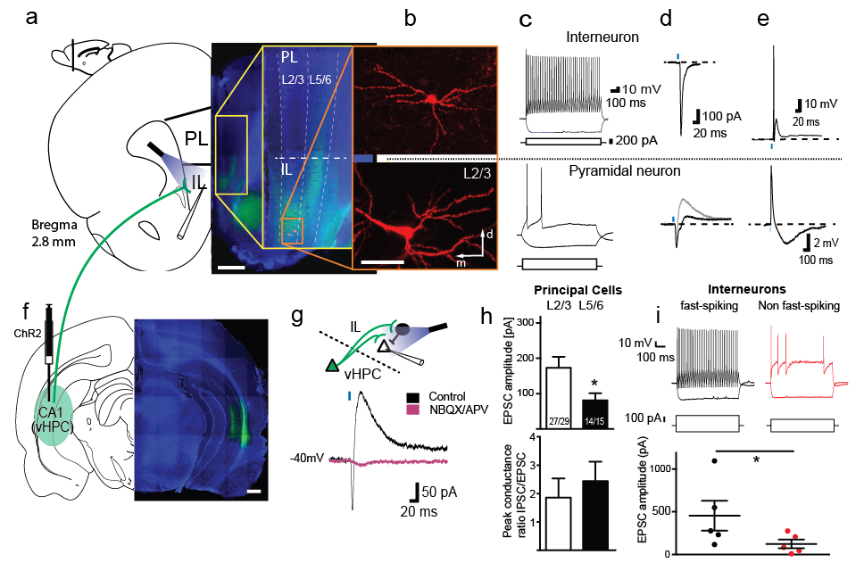

**Figure 1 | Sub-layer specific analysis of the hippocampal projection to the mPFC reveals strong local feed-forward inhibition mediated by fast-spiking interneurons. a**, Schematic and actual coronal image of terminal labeling in the IL following ChR2 injection in the CA1 region of the vHPC (**f**). Scale bars for a and f: 1 mm. **b**, Biocytin-recovered IL neurons in L2/3 (scale bar: 20 μm) with the corresponding intrinsic firing properties (**c**), voltage clamp recordings (**d**, black traces: -60 mV holding potential; grey trace: -40 mV holding potential), and current clamp recordings (**e**) following terminal release. Note that terminal release in the interneurons causes the cell to spike (current clamp, top trace). **g**, Example of a synaptic response in a L2/3 pyramidal neuron in the IL that shows a monosynaptic EPSC, followed by a feed-forward inhibitory current (black trace). Both the EPSC and IPSC are eliminated in the presence of the AMPA- and NMDA-receptor antagonists NBQX and APV, respectively (purple trace). **h**, Bar graph of EPSC amplitudes (top) and peak conductance ratios of IPSC/EPSC components (measured at -40 mV) of L2/3 and L5/6 pyramidal neurons. Values inside the bars state amount of responding neurons/investigated neurons. **i**, Comparison of EPSC amplitudes in fast-spiking (left in black) and non fast-spiking interneurons (right in red) revealed significantly larger inputs onto fast spiking cells. Current injections are shown below the firing traces. *p<0.05. DAPI: blue. Blue bars illustrate 470 nm light stimulation. Error bars represent mean ± SEM.

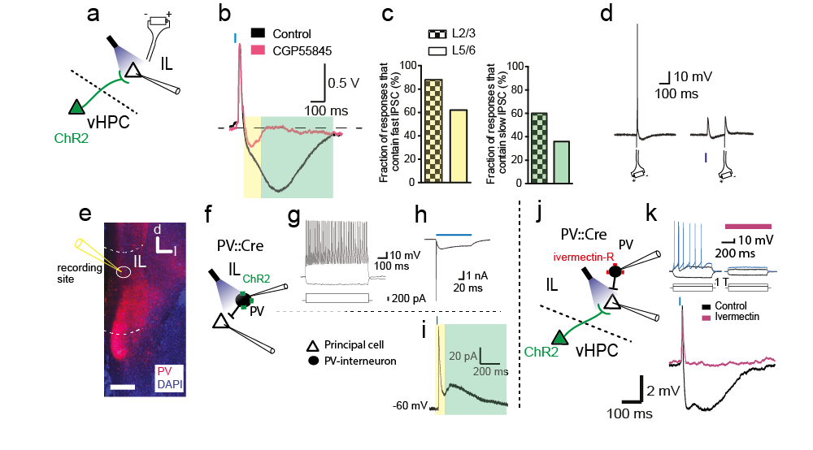

**Figure 2 | Hippocampus-driven disynaptic IPSC onto PCs suppresses their excitability and is mediated by parvalbumin-positive interneurons.** a, Illustration of optical terminal stimulation of ventral hippocampal inputs and simultaneous investigation of principal cells (PCs) in the IL. Local electrical stimulation (battery symbol) was used to study suppression of spiking in (d). b, Voltage-clamp responses to hippocampal terminal release before (black trace) and after (purple trace) the application of the GABAB-receptor antagonist CGP55845, revealing the fast IPSC (yellow) and slow IPSC (green). c, Bar graphs depicting percentages of PCs in L2/3 (checkerboard) or L5/6 (boxed) that contain a fast disynaptic IPSC (yellow) or a slow IPSC (green).d, Spiking of PCs in the IL by local electrical stimulation was suppressed by preceeding optical stimulation (150 ms earlier) that recruits hippocampal inputs. e, coronal section containing the IL shows PV cell labeling (red) and the recording site (white circle). DAPI: blue. Scale bar: 500 μm. f, Schematic of specific infection of PV cells with ChR2 to study the source of the disynaptic current. g, Current injection (steps shown below the traces) revealed typical intrinsic firing patterns for PV cells. h, Infected PV cells showed initial spiking, followed by maintained inward-current throughout the light stimulation (100 ms). i, Investigated principal cells to optical terminal release typically showed both fast (yellow) and slow IPSCs (green). j, Schematic for the expression of ivermectin-receptors (red) to silence PV cells and simultaneous optical activation of hippocampal inputs that allowed investigation of the slow disynaptic inhibitory current specific to HPC projections. k, (top) Investigation of PV-cells expressing ivermectin-receptors fail to show intrinsically induced spiking in the presence of ivermectin. (bottom) Current-clamp response to optical terminal stimulation of HPC inputs before (black) and after (purple) ivermectin washin showed full blockage of both inhibitory components, which reveals hippocampus-driven feed-forward inhibition of pyramidal cellss by PV cells. 1 T: Current injection to achieve threshold firing.

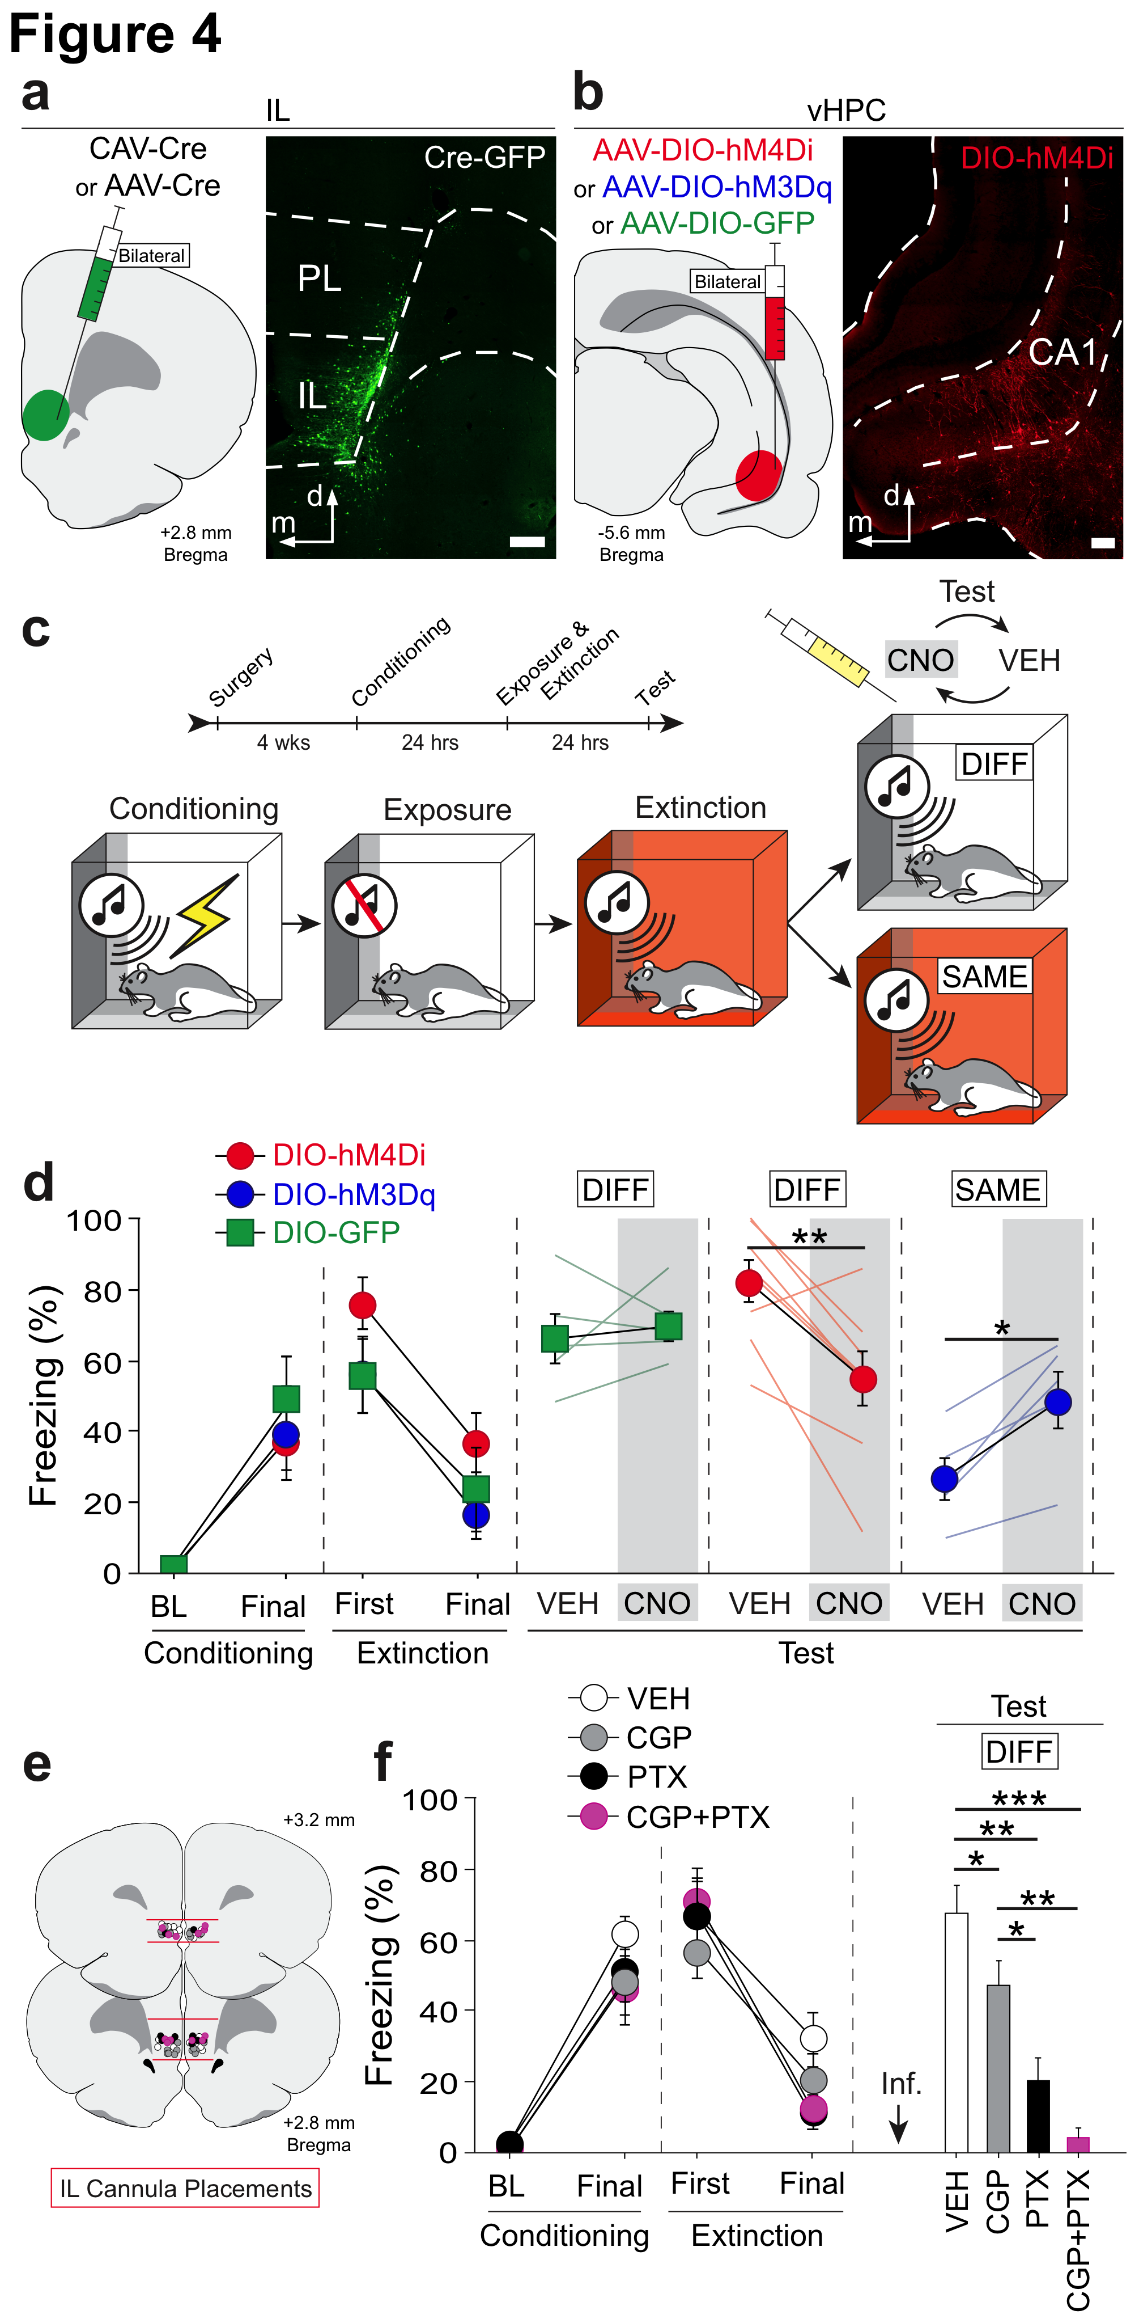

**Fig 3. | vHPC-mediated feed-forward inhibition of the IL promotes fear relapse.** **a**, Cre-expressing retrograde virus bilaterally infused into the IL (left); infusion sites confirmed by co-infused AAV8-hSyn-GFP (right). **b**, Cre-dependent viruses expressing hM4D(Gi)-mCherry, hM3D(Gq)-mCherry or GFP bilaterally infused into the vHPC (left); mCherry expression in vHPC->IL neurons in CA1 of the vHPC (right). **c**, Rats received fear conditioning (context A), context exposure (context A) and extinction (context B) before being tested either outside of the extinction context (DIFF) or in the extinction context (SAME). All tests were performed after CNO or VEH administration in counterbalanced within-subjects design. **d**, CNO silencing of vHPC->IL decreased fear renewal (red circle), *n*=8; CNO had no effect on fear renewal in GFP control rats (green square), *n*=5; CNO activation of vHPC->IL led to fear relapse (blue circle), *n*=5. Test data show average freezing during 5-tone presentations. **e**, Bilateral IL cannula placement with 30 degree angle. **f**, Microinfusions of CGP55845, picrotoxin or both in IL decreased fear renewal. VEH *n*=11; CGP *n*=10; PTX *n*=5; CGP+PTX *n*=6. Test data show average freezing during five 30s-ITI. \**P* < 0.05; \*\**P* < 0.01; \*\*\**P* < 0.001. Error bars indicate means ± SEM.

**METHODS**

**Subjects.** A total of 50 Long-Evans male adult rats (200–224 g; Blue-Spruce, Harlan, Indianoplis, IN) were used for the behavioral experiments: 18 rats were used in the vHPC->IL DREADD experiments and 32 rats were used for the IL microinfusion experiment. The rats were individually housed on a 14/10 h light/dark cycle and had access to food and water *ad libitum*. Rats were handled for 5 days after arrival. All experimental procedures were performed in accordance with the protocols approved by the Texas A&M University Animal Care and Use Committee.

**Viruses and drugs.** AAV5-hSyn-DIO-hM4D(Gi)-mCherry (5.7×10e12 pp/mL), AAV8-hSyn-DIO-GFP and AAV5-hSyn-DIO-hM3D(Gq)-mCherry (6.7×10e12 pp/mL) were obtained from the University of North Carolina Vector core. CAV2-Cre (8.7×10e12 pp/mL) was from IGMM, France and AAV5-Cre-eGFP (1.62×10e13 GC/ml) was from University of Pennsylvania vector core. CNO was obtained from NIMH (Chemical synthesis and drug supply program); CGP55845 was from Tocris Bioscience and picrotoxin was from Sigma-Aldrich.

**Surgical procedures.** For the vHPC->IL DREADD experiments, rats were anesthetized with isoflurane (5% for induction and kept at 2~2.5% during surgery), and were placed into stereotaxic apparatus (David Kopf Instruments) for viral injection. For the inhibitory DREADD experiment, 13 rats were bilaterally injected with CAV2-Cre in IL and AAV8-hSyn-DIO-hM4D(Gi)-mCherry or AAV-hSyn-DIO-GFP in vHPC. For the excitatory DREADD experiment, 5 rats were bilaterally injected with AAV5-Cre-eGFP in IL and AAV5-hSyn-DIO-hM3D(Gq)-mCherry in vHPC. All the viruses were injected (0.15 µl/min) using an injector connected to polyethylene tube and a Hamilton syringe (10 µl) mounted on an infusion pump. Four injections (0.5 µl/injection) were made into the vHPC at two different AP levels: AP -5.2, ML 6.0, DV -6.5; AP -5.2, ML 6.0, DV -5.3; AP -6.1, ML 6.0, DV -6.1; AP -6.1, ML 6.0, DV -5.0 (all DV coordinates are measured from dura). One injection (1.8 µl) was made in the IL in each hemisphere at AP +2.8, ML 3.0, DV -4.9 with a 30-degree angle. Rats were placed back in their home cages to allow for viral expression at least for 4 weeks.

For the IL microinfusion experiment, rats were anesthetized with isoflurane (5% for induction and kept at 2~2.5% during surgery), and were placed into stereotaxic apparatus (David Kopf Instruments) for cannula implantation. Steel guide cannulae (26 gauge, 8 mm; Small Parts) were lowered into the IL (AP +2.7, ML 3.0, DV -4.9) with 30-degree angle to limit drug diffusion into the PL. Stainless steel obturators (30 gauge, 9 mm; Small Parts) were placed in each guide cannula and were changed twice prior to behavioral tests. The rats were allowed for 1 week of post-operative recovery in their home cage.

**Behavioral apparatus.** Behavioral testing was conducted in two distinct rooms in the laboratory. Eight identical conditioning chambers (30×24×21 cm; MED-Associates) in each room were used in all behavioral experiments. The chambers consisted of aluminum sidewalls, Plexiglas ceiling, rear wall, and hinged front door. The floor of each chamber consisted of 19 stainless steel rods that were wired to a shock source and a solid-state grid scrambler (MED-Associates) for delivery of foot shock (US). A speaker mounted in one wall of the chamber was used for delivery of acoustic CS, and ventilation fans and house lights were installed in each chamber to allow for the manipulation of contexts. Each chamber rests on a load-cell platform that is used to record chamber displacement in response to each rat’s motor activity and is acquired online via Threshold Activity software (MED Associates). Absolute values of the load-cell voltages are computed and multiplied by 10 to yield a scale that ranges from 0 to 100. For each chamber, load-cell voltages are digitized at 5 Hz, yielding one observation every 200 ms. Freezing is quantified by computing the number of observations for each rat that has a value less than the freezing threshold (load-cell activity=10). Freezing is only scored if the rat is immobile for at least 1 s. Sensory stimuli were adjusted within these chambers to generate two distinct contexts A and B. For context A, a 15-W house light mounted on the sidewall was turned on, and the white room light remained on. Ventilation fans (65 dB) were turned on, cabinet doors were left open, and the chambers were cleaned with 1% ammonium hydroxide. Rats were transported to context A in white plastic boxes. For context B, house light and white room light were all turned off, and fluorescent red room light was turned on. Ventilation fans were turned off, the cabinet doors were closed and the chambers were cleaned with 1% acetic acid. Rats were transported to context B in black plastic boxes. In each context, stainless steel pans were filled with a thin layer of the respective odors of the contexts and inserted below the grid floor.

**Behavioral procedures.** At least 4 weeks after viral surgery, rats underwent fear conditioning in context A on day 1. Conditioning consisted of five tone (CS; 10 s, 80 dB, 2 kHz)-footshock (US; 1.0 mA, 2 s) pairings with 60 s intertrial intervals (ITIs). On day 2 and 3, rats received context exposure in context A for 35 min 30 s in the morning, and received 45 tone-alone (10 s, 80 dB, 2 kHz, 30 s ITIs) extinction training in context B in the afternoon. On day 4 and 5, hM4D(Gi) and GFP rats received renewal tests in context A, and hM3D(Gq) rats received extinction retention tests in context B. Before each tests, rats all received systemic injection of CNO [1mg/kg for hM4D(Gi) and 2 mg/kg for hM3D(Gq)] or VEH in within-subjects manner. The order of the drug injection was counterbalanced. Test session consisted of 10 min baseline test and five tone-alone (10 s, 80 dB, 2 kHz, 30 s ITIs) presentations. In all behavioral sessions, the chamber position of each animal was counterbalanced.

For IL microinfusion experiment, rats underwent day 1 fear conditioning (context A), day 2 context exposure in the morning (context A) and extinction in the afternoon (context B), and day 3 renewal test (context A). Variables used for conditioning, exposure, extinction and tests are identical to DREADD experiment. Ten minutes prior to the renewal test, rats received microinfusion of either CGP (10 mM), PTX (0.33 mM), cocktail of both or vehicle into IL. Rats received intracranial infusion with 0.6 µl of drug (0.3 µl per hemisphere) over 1 min at a rate of 0.3 µl/min.

**Immunohistochemistry.** Rats were overdosed with sodium pentobarbital (Fatal Plus; 100 mg/ml, 0.5 ml) and were transcardially perfused with saline and 10% formalin. Brains were extracted and post-fixed in formalin solution for 24 h at 4 °C and transferred to 20% sucrose. Brains were then flash frozen with dry ice and sectioned (40 mm) on a cryostat maintained at -20 °C. Sections containing vHPC were collected for immunohistochemistry. Immunohistochemistry was performed on free-floating brain sections. The tissue was washed three times in 1×Tris-buffered saline (TBS, pH 7.4). Brain sections were then incubated in 10% normal donkey serum (NDS) in TBST for 1 h at room temperature followed by two washes in TBST for 5 min. Tissue was then incubated in primary antibody solution in TBST with 2% NDS (rabbit anti-mCherry antibody at 1:2000; Abcam) for 48 h at 4 °C. Brain sections were then washed three times in TBST for 10 min and were incubated in secondary antibody solution in TBST with 2% NDS (AF594 conjugated donkey anti-rabbit at 1:200; Abcam) for 2 h at room temperature. Tissue was washed three times in TBS for 10 min and then was mounted on subbed slides in 0.9% saline and cover slipped with Fluoromount (Sigma-Aldrich). Brain sections containing the IL were wet mounted to microscope slides and cover slipped with Fluoromount for imaging.

**Statistics.** Paired t-test was used to analyze DREADD experiment data in hM4D(Gi), GFP and hM3D(Gq) experiment separately. IL microinfusion data were analyzed with repeated measured analysis of variance (ANOVA) and one-way ANOVA. Post-hoc comparisons in the form of Fisher’s protected least significant difference (PLSD) post hoc tests, which were performed after a significant overall F ratio. All data are represented as means ± SEM.

Methods Sah part

## *Animals*

13 Wistar rats and 7 PV-cre knockin (C57BL/6 strain) mice (4 for the local optical PV stimulation and 3 for the ivermectin-receptor silencing experiments) were used in the *ex-vivo* experiments. The animals were houses in a 12h/12h light/dark cycle with access to food and water *ad libitum*. All procedures were conducted in accordance with the guidelines of the University of Queensland animal ethics committee. The amount of animals used for the experiments was kept as low as possible.

## *In vivo injection*s

Animals (p25-45) were anesthetized with an intraperitoneal injection of Ketamine/Xylazine (10%/5%; 0.1 mL/10 g; rats: addition of Zoletil at 4uL/10 g body weight). Animals were then places in a stereotactic frame. An incision at the midline was made using a single edged blade. For the investigation of hippocampal projections to the mPFC, 0.3-0.5 μL of AAV2/5.CAG.ChR2-Venus.WSV40 / AAV2.5.hSyn.hChR2(H134R).eYFP.WPRE.hGH (Penn Vector Core, Philadelphia, titer: 1.1e13) were injected in the vHPC of rats. For the investigation of amygdala-projecting IL neurons, the vHPC injection was combined with retrobeads injections into the amygdala (0.3-0.5uL, red RetroBeads, Lumafluor; amygdala coordinates from bregma in mm (anterior/posterior; medial/lateral (angle); dorsal/ventral): -2; ±1.2 (±22°); -9.3). For the study of local PV-projections, 1.5-2 μL of AAV5.EF1a-dflox-hChR2(H134R)-mCherry.WPRE (produced in-house) were injected into the IL of PV-cre mice (coordinates from bregma in mm: anterior/posterior; medial/lateral; dorsal/ventral: 1.8; ±0.2; -2.3). For the silencing approach using ivermectin-receptors, IL injection of AAV2/1 EF1a-DIO-IVM-CFP (produced in-house; same IL coordinates) was combined with vHPC injections in the vHPC of PV-cre mice (coordinates from bregma in mm: anterior/posterior; medial/lateral; dorsal/ventral: 3.3; ±2.7; -3.5). Injections were done at a rate of 0.1-0.2uL/min via 30-gauge needles coupled to a 5 μL Hamilton syringe in a syringe pump (Harvard PicoPlus). The needle was slowly removed five min after the injection was finished. The incision was then disinfected and closed using vetbond tissue adhesive and stitched. Baytril (1 μL/10 g) and Metacam (4 μL/10 g) were each diluted in 0.5 mL of saline injected subcutaneously. The following coordinates were used for stereotactic injections (anterior/posterior; medial/lateral (angle); dorsal/ventral): amygdala:; vHPC: -6; ± 5.3; -4; IL: 2.5; ±2.9 (34°); -4.5. Coordinates for the stereotactic injections were based on the Paxinos&Watson rat atlas (the rat brain atlas, 6th edition)

Electrophysiological experiments were commenced at least 28 d after the virus injections to allow terminal expression. Single-cell recordings of neurons and application of brief light pulses (470nm; 5ms) using an LED source (CoolLED) were performed to study the location and pharmacological properties of synaptic connections onto mPFC neurons. Only injected animals with at least one successful synaptic response at the projection site were included in the analysis. Light stimulation was kept maximal, except for cases where a decrease in light stimulation eliminated the polysynaptic component, but didn’t diminish the initial component.

|  |  |  |  |
| --- | --- | --- | --- |
|  |  |  |  |

## *Electrophysiology*

Animals were anaesthetized with isoflurane (1ml; applied in enclosed container) and then decapitated. Brains were rapidly removed and placed in ice cold cutting solution containing (mM): NaCl 118, KCl 2.5, NaHCO3 25, glucose 10, MgCl2 4, CaCl2 0.5 and NaH2PO4 1.2. Coronal brain slices (300 μm) were prepared using a vibratome (Leica VT 1000S). Slices were allowed to recover in oxygenated (95% O2/5% CO2) artificial cerebrospinal fluid (aCSF) (in mM: NaCl 118, KCl 2.5, NaHCO3 25, glucose 10, MgCl2 1.3, CaCl2 2.5 and NaH2PO4 1.2) at 35°C for at least 30 min, then kept at room temperature for at least another 30 min before experiments were commenced. Slices were transferred to the recording chamber as required and were continuously perfused with oxygenated aCSF through a gravity fed system and maintained at 30-32°C. In cases where either a virus or a tracer was injected, slices containing the injection sites were also kept to determine localized injection sites. Slices were visualized using an upright microscope (BX50WI, Olympus Optical, Tokyo, Japan) with a 5x NA 0.1 or 40x NA 0.8 objective and infrared and differential interference contrast optics. Fluorescent neurons were visualized by using an LED system (pE-2, CoolLED) and YFP/RFP filter sets (Olympus). Electrodes (3-7 MΩ) were filled with a pipette solution containing (mM): KMeSO4 135, NaCl 7, HEPES 10, Mg2ATP 2, Na3GTP 0.3, EGTA 0.3, biocytin 8 (pH 7.3 with KOH, osmolarity ~290 mOsm/kg). Signals were recorded using a patch clamp amplifier (Multiclamp 700B, Axon instruments). Sampling rate was 20 kHz and signals were digitized at 2 kHz (Instrutech, ITC-16). All data were acquired, stored and analyzed using Axograph X (Axograph, V 1.2.1). For all the voltage-clamp recordings, cells were held at -60 to -70 mV by injecting current if needed and cells with a resting membrane potential above -55mV were excluded from the analysis. For current-clamp recordings, recordings were corrected for bridge-balance and pipette resistance. All investigations were performed on the ipsilateral site of injection. Access resistance was 5-25 MΩ and was monitored throughout the experiment (cells with access resistance changes >25% were excluded). Drugs were bath applied by using a gravity-fed system that allowed continuous change of solutions. For optogenetic stimulation, 470 nm light pulses were applied with a CoolLed system (pE-2) attached to the upright microscope (Olympus BX51WI). 5ms pulses were applied to evoke postsynaptic responses and 200ms pulses were used to study infected neurons. Maximal light output at 470 nm was measured at 2mW (ThorLabs, optical power meter). Electrophysiolocigal responses were analysed using AxoGraph. For synaptic responses, an average of 5-10 traces were taken for analysis. For optogenetic stimulation, only samples with at least one synaptic response to maximal intensity light pulses were used for the statistics. Electrical stimulation (at 0.1 ms using a stimulator-box) was done by using a patch-clamp pipette filled with 3M saline and the ground loop wire was place in the bath. Intrinsic firing properties were analysed at current injections of two-fold threshold firing. Drug application of Picrotoxin (100 μM), CGP55845 (1 mM), NBQX (20 mM) and APV (100 mM) (all from tocris) were done through a gravity fed system. Analytical tests were performed with SPSS (IBM) or Prism (GraphPad). Outliers were determined by Grubb’s test (http://graphpad.com/quickcalcs/Grubbs1.cfm). Graphs were created using Adobe Illustrator CS5. All results are expressed as mean ± s.e. mean.

## *Immunohistochemistry*

For biocytin recovery and immunohistochemistry, brain slices were fixed with 4% paraformaldehyde in 0.1M PB for 40-60 min at room temperature. Slices were washed three times with 0.1M PBS, then blocked with blocking solution containing: PBS 0.1M, bovine serum albumin (3%), saponin (0.1%) and sodium azide (0.05%) for 1 h at room temperature. Slices were washes with PBS and incubated in primary antibodies including anti-TBR1 and streptavidin –Alex fluor 488/555/647 (1:1000, Invitrogen) for 1-3 days at room temperature or at 4°C. Sections were washed 3 X 15 min in PBS and Alexa-conjugated species-specific secondary antibodies (1:1000, Jackson Biosciences or Invitrogen) for at least 5 h at room temperature. After a triple wash with PBS, the brain slices where mounted in glycerol/PBS (50%/50%) or PBS only for tissues containing retrograde tracers. Slices were imaged using an upright microscope (5x or 20x, Zeiss, Axio Imager) or a confocal system (20x, Zeiss LSM510). Images were produced by flattening z-stacks (1 μm intervals) to a maximum projection image using Zen 2011 software (Zeiss).



**Extended Data Figure 1 | Amygdala-projecting neurons in the IL also receive input from the vHPC**. **a**, Illustration for the investigation of amygdala-projecting IL neurons that receive innervation from the vHPC by combining retrograde tracer injections in the amygdala and ChR2-expression in the vHPC. **b**, A typical intrinsic firing patterns to positive and negative current injections (shown below traces) for amygdala-projecting pyramidal neurons. **c**, Typical voltage-clamp (left) and current clamp (right) responses to optical stimulation of an amygdala-projecting IL pyramidal neuron. **d**, Bar graph showing the comparison of the IPSC/EPSC peak conductance ratio (left) and EPSC amplitudes (right) for control neurons (white) and amygdala-projecting neurons (red).

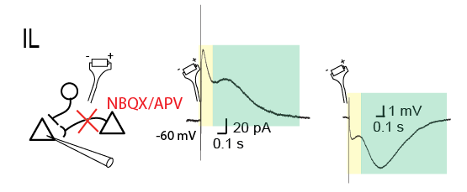

**Extended Data Figure 2 | Feed-forward inhibition onto pyramidal cells is mediated by local IL interneurons**. Electrical stimulation (battery symbol) of IL tissue in-vitro in the presence of AMPA- and NMDA-receptor antagonists NBQX and APV (schematic on the left), respectively, reveal inhibitory conductances that contain both fast (yellow) and slow (green) inhibitory components in voltage-clamp (middle) and current-clamp mode (right).

**Macintosh HD:Users:marenlab:Desktop:IN PROGRESS:Extended-Data-Figure1.pdf**

**Extended Data Figure 4 | CNO-dependent silencing of hM4D(Gi)-expressing neurons in freely moving rats.** **a**, Following five days of handling (~30 s/day), anesthetized rats (three total) received bilateral stereotaxic infusions (2.0 μl/per infusion; 0.3 μl/min with 5 min of diffusion time) of AAV5-CamKIIα-hM4D(Gi)-mCherry (one rat) or AAV5-CamKIIα-mCherry (two rats) in IL (+2.7 anterior to bregma, ±0.45 to the midline, -5.1 ventral to bregma; 30° angle from the midline). Rats were then implanted with a 16-channel microelectrode array within the right hemisphere of the mPFC (8 channels in IL; 8 channels in PL) as previously described$. Representative image depicts DREADD-expressing cells within IL (40 μm coronal section; white bar inset=250 μm). **b**, Two weeks after surgery, rats underwent three 70 min recording sessions across three consecutive days (one session/day) in a standard testing chamber (extracellular single-unit activity was recorded and analyzed as previously described$). Rats were injected (i.p.) with CNO (1 or 3 mg/kg) or vehicle (counterbalanced) following a 10 min baseline period and remained in the chamber for 60 additional minutes. Each neuron was z-score normalized to its 10 min baseline firing rate (20 s bins). No significant change in the spontaneous activity of IL neurons (*n*=15 for hM4D(Gi); *n*=27 for mCherry control) was detected across groups when animals were injected with vehicle (left). When the hM4D(Gi)-expressing animal was injected with 1 mg/kg (middle) or 3 mg/kg (right) of CNO, IL neurons (*n*=18 for 1 mg/kg; *n*=16 for 3 mg/kg) exhibited a significant reduction in spontaneous firing relative to neurons of control virus-infected animals (*n*=25 for 1 mg/kg; *n*=25 for 3 mg/kg; repeated measures ANOVA, main effects of virus: *F*1,40=10.957, *P*<0.01 for 1 mg/kg, *F*1,37=24.440, *P*<0.001 for 3 mg/kg). \*\**P*<0.01, \*\*\**P*<0.001.

$Fitzgerald, P.J. *et al.* Noradrenergic blockade stabilizes prefrontal activity and enables fear extinction under stress. *PNAS* **112**, E3729-E3737 (2015)

**Extended Data Figure 5 | Pharmacogenetic silencing of vHPC neurons disrupts fear renewal. a**, Following five days of handling (~30 s/day), anesthetized rats received two bilateral stereotaxic infusions (1.0 μl/per infusion; 0.25 μl/min with 8 min of diffusion time) of AAVdj8-CamKIIα-hM4D(Gi)-mCherry or AAV8-CamKIIα-GFP in the ventral hippocampus (site one: -5.2 anterior to bregma, +/-5.5 to the midline, -7.4 ventral to dura; site two: -5.95 anterior to bregma, +/-5.5 to the midline, -6.8 ventral to dura). Representative coronal (40 μm) sections of hM4D(Gi)- and GFP-expressing tissue are shown (white bar inset=250 μm). **b**, Two weeks after surgery, rats underwent ‘ABA’ renewal. Rats were fear conditioned to an auditory CS (10 s, 2 kHz, 80 dB) in context A via five tone-footshock (unconditioned stimulus, US; 2 s, 1 mA) pairings (separated by 1 min intertrial intervals). Conditioning data show mean freezing across 3 min of acclimation to the context (baseline, ‘BL’) and across the final minute in the chamber (‘Final’). 24 hrs after conditioning, rats underwent four days of exposure (35 min/day) to the conditioning context and extinction to the CS in conte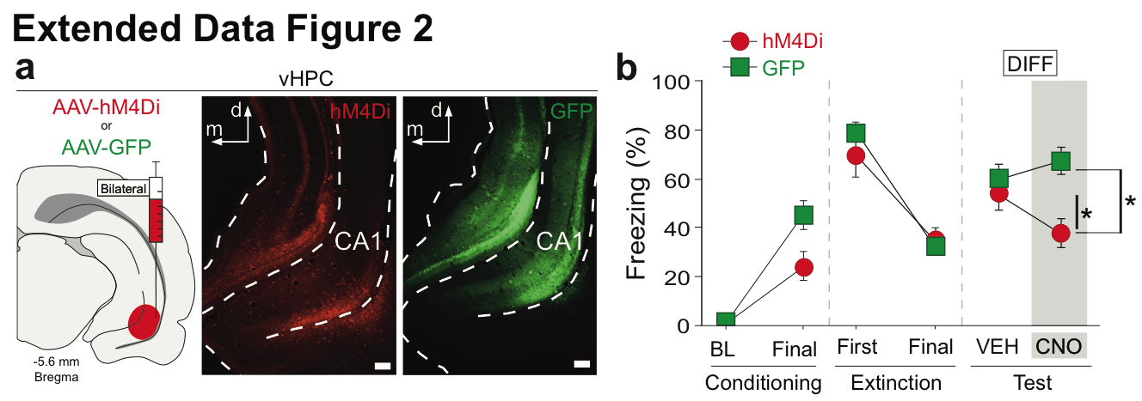xt B (45 CS-only presentations/day; 3 min BL, 30 s intervals). Extinction data depict mean freezing across the first day of extinction (forty-five post-CS intervals, ‘First’) and across the final day of extinction (forty-five post-CS intervals, ‘Final’). In a counterbalanced within-subjects design across two days, hM4D(Gi)- (*n*=7) and GFP-expressing (*n*=17) rats were tested to the extinguished CS (5 trials per session) outside of the extinction context (in context A) both on and off CNO. Test data show mean freezing across five 30 s post-CS intervals. Two-way repeated measures ANOVA revealed a significant virus x drug interaction (*F*1,22=4.478, *P*<0.05). Split by virus, a main effect of drug trial (*F*1,6=6.002, *P*<0.05) indicated that hM4D(Gi)-expressing animals exhibited significantly less fear when on CNO as compared to when those same animals were treated with vehicle. Conversely, GFP-expressing animals did not significantly differ across their respective drug treatments. Post-hoc comparisons (Fisher’s protected least significant difference [PLSD]) indicated that CNO-treated hM4D(Gi) animals exhibited significantly less freezing than vehicle- or CNO-treated GFP-expressing animals (*Ps*<0.5). No effect of drug order was detected. Three rats were excluded from the hM4D(Gi) group for exhibiting unilateral expression; two other rats were excluded for exhibiting off-target infection in cortical regions. All hM4D(Gi) rats included in these analyses (*n*=7) exhibited expression in ventral subiculum and ventral CA1. No GFP rats were excluded based on fluorophore expression. \**P*<0.05. Error bars indicate means ± SEM.

References

1 Quirk, G. J. *et al.* Erasing fear memories with extinction training. *The Journal of Neuroscience* **30**, 14993-14997, doi:10.1523/JNEUROSCI.4268-10.2010 (2010).

2 Milad, M. R. & Quirk, G. J. Fear extinction as a model for translational neuroscience: ten years of progress. *Annu Rev Psychol* **63**, 129-151, doi:10.1146/annurev.psych.121208.131631 (2012).

3 Herry, C. *et al.* Neuronal circuits of fear extinction. *Eur J Neurosci* **31**, 599-612, doi:EJN7101 [pii]

10.1111/j.1460-9568.2010.07101.x (2010).

4 Ji, J. & Maren, S. Hippocampal involvement in contextual modulation of fear extinction. *Hippocampus* **17**, 749-758, doi:10.1002/hipo.20331 (2007).

5 Sotres-Bayon, F., Sierra-Mercado, D., Pardilla-Delgado, E. & Quirk, G. J. Gating of fear in prelimbic cortex by hippocampal and amygdala inputs. *Neuron* **76**, 804-812, doi:10.1016/j.neuron.2012.09.028 (2012).

6 Corcoran, K. A., Desmond, T. J., Frey, K. A. & Maren, S. Hippocampal inactivation disrupts the acquisition and contextual encoding of fear extinction. *J Neurosci* **25**, 8978-8987, doi:10.1523/JNEUROSCI.2246-05.2005 (2005).

7 Sotres-Bayon, F. & Quirk, G. J. Prefrontal control of fear: more than just extinction. *Curr. Op. Neurobiol.* **20**, 231-235, doi:10.1016/j.conb.2010.02.005 (2010).

8 Parent, M. A., Wang, L., Su, J., Netoff, T. & Yuan, L. L. Identification of the hippocampal input to medial prefrontal cortex in vitro. *Cereb Cortex* **20**, 393-403, doi:10.1093/cercor/bhp108 (2010).

9 Hoover, W. B. & Vertes, R. P. Anatomical analysis of afferent projections to the medial prefrontal cortex in the rat. *Brain structure & function* **212**, 149-179, doi:10.1007/s00429-007-0150-4 (2007).

10 Milad, M. R. & Quirk, G. J. Neurons in medial prefrontal cortex signal memory for fear extinction. *Nature* **420**, 70-74, doi:10.1038/nature01138 (2002).

11 Laurent, V. & Westbrook, R. F. Inactivation of the infralimbic but not the prelimbic cortex impairs consolidation and retrieval of fear extinction. *Learning & memory* **16**, 520-529, doi:10.1101/lm.1474609 (2009).

12 McDonald, A. J., Mascagni, F. & Guo, L. Projections of the medial and lateral prefrontal cortices to the amygdala: a Phaseolus vulgaris leucoagglutinin study in the rat. *Neurosci.* **71**, 55-75. (1996).

13 Ascoli, G. A. *et al.* Petilla terminology: nomenclature of features of GABAergic interneurons of the cerebral cortex. *Nat Rev Neurosci* **9**, 557-568, doi:nrn2402 [pii]

10.1038/nrn2402 (2008).

14 Tamas, G., Lorincz, A., Simon, A. & Szabadics, J. Identified sources and targets of slow inhibition in the neocortex. *Science* **299**, 1902-1905, doi:10.1126/science.1082053 (2003).

15 Wozny, C. & Williams, S. R. Specificity of synaptic connectivity between layer 1 inhibitory interneurons and layer 2/3 pyramidal neurons in the rat neocortex. *Cereb Cortex* **21**, 1818-1826, doi:10.1093/cercor/bhq257 (2011).

16 Tierney, P. L., Degenetais, E., Thierry, A. M., Glowinski, J. & Gioanni, Y. Influence of the hippocampus on interneurons of the rat prefrontal cortex. *Eur J Neurosci* **20**, 514-524, doi:10.1111/j.1460-9568.2004.03501.x (2004).

17 Kawaguchi, Y. & Kondo, S. Parvalbumin, somatostatin and cholecystokinin as chemical markers for specific GABAergic interneuron types in the rat frontal cortex. *J Neurocytol* **31**, 277-287 (2002).

18 Lerchner, W. *et al.* Reversible silencing of neuronal excitability in behaving mice by a genetically targeted, ivermectin-gated Cl- channel. *Neuron* **54**, 35-49, doi:S0896-6273(07)00170-5 [pii]

10.1016/j.neuron.2007.02.030 (2007).

19 Lynagh, T. & Lynch, J. W. An improved ivermectin-activated chloride channel receptor for inhibiting electrical activity in defined neuronal populations. *J Biol Chem* **285**, 14890-14897, doi:M110.107789 [pii]

10.1074/jbc.M110.107789 (2010).

20 Do-Monte, F. H., Manzano-Nieves, G., Quinones-Laracuente, K., Ramos-Medina, L. & Quirk, G. J. Revisiting the role of infralimbic cortex in fear extinction with optogenetics. *J Neurosci* **35**, 3607-3615, doi:10.1523/JNEUROSCI.3137-14.2015 (2015).

21 Likhtik, E., Pelletier, J. G., Paz, R. & Pare, D. Prefrontal control of the amygdala. *J Neurosci* **25**, 7429-7437, doi:10.1523/JNEUROSCI.2314-05.2005 (2005).

22 Bukalo, O. *et al.* Prefrontal inputs to the amygdala instruct fear extinction memory formation. *Sci Adv* **1**, doi:10.1126/sciadv.1500251 (2015).

23 Hobin, J. A., Ji, J. & Maren, S. Ventral hippocampal muscimol disrupts context-specific fear memory retrieval after extinction in rats. *Hippocampus* **16**, 174-182, doi:10.1002/hipo.20144 (2006).

24 Duvarci, S. & Pare, D. Amygdala microcircuits controlling learned fear. *Neuron* **82**, 966-980, doi:10.1016/j.neuron.2014.04.042 (2014).

25 Herry, C. *et al.* Switching on and off fear by distinct neuronal circuits. *Nature* **454**, 600-606, doi:nature07166 [pii]

10.1038/nature07166 (2008).